相关证书
认证体系证书
http://cx.cnca.cn/CertECloud/result/skipResultList?certNumber=&orgName=%E6%B3%97%E6%B4%AA%E5%8E%BF%E6%B0%B4%E5%88%A9%E5%B7%A5%E7%A8%8B%E6%9C%89%E9%99%90%E5%85%AC%E5%8F%B8&fromIndex=true
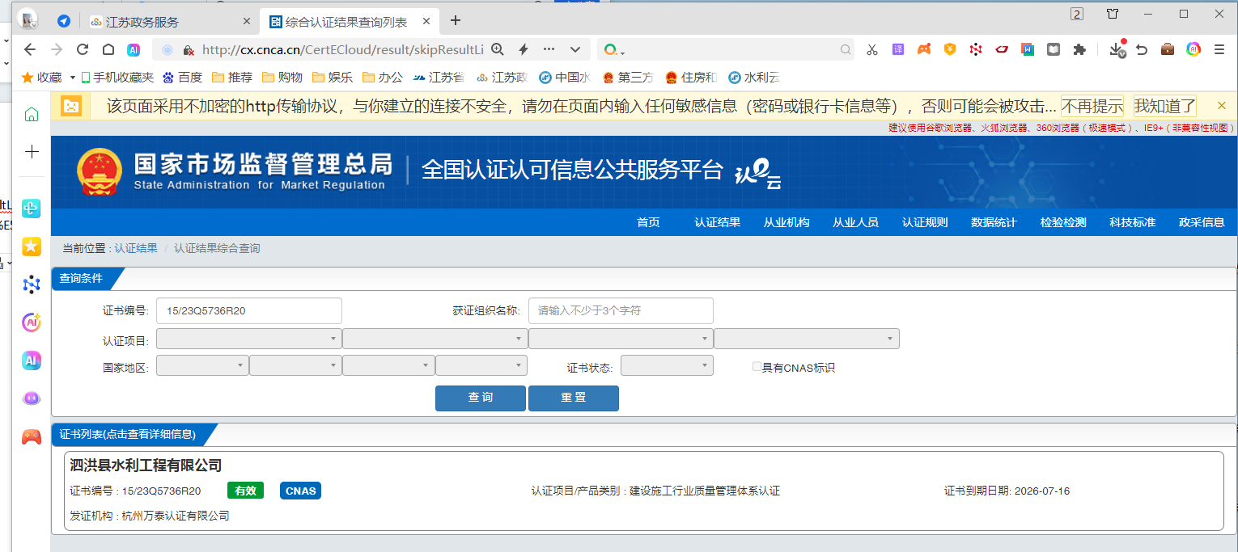
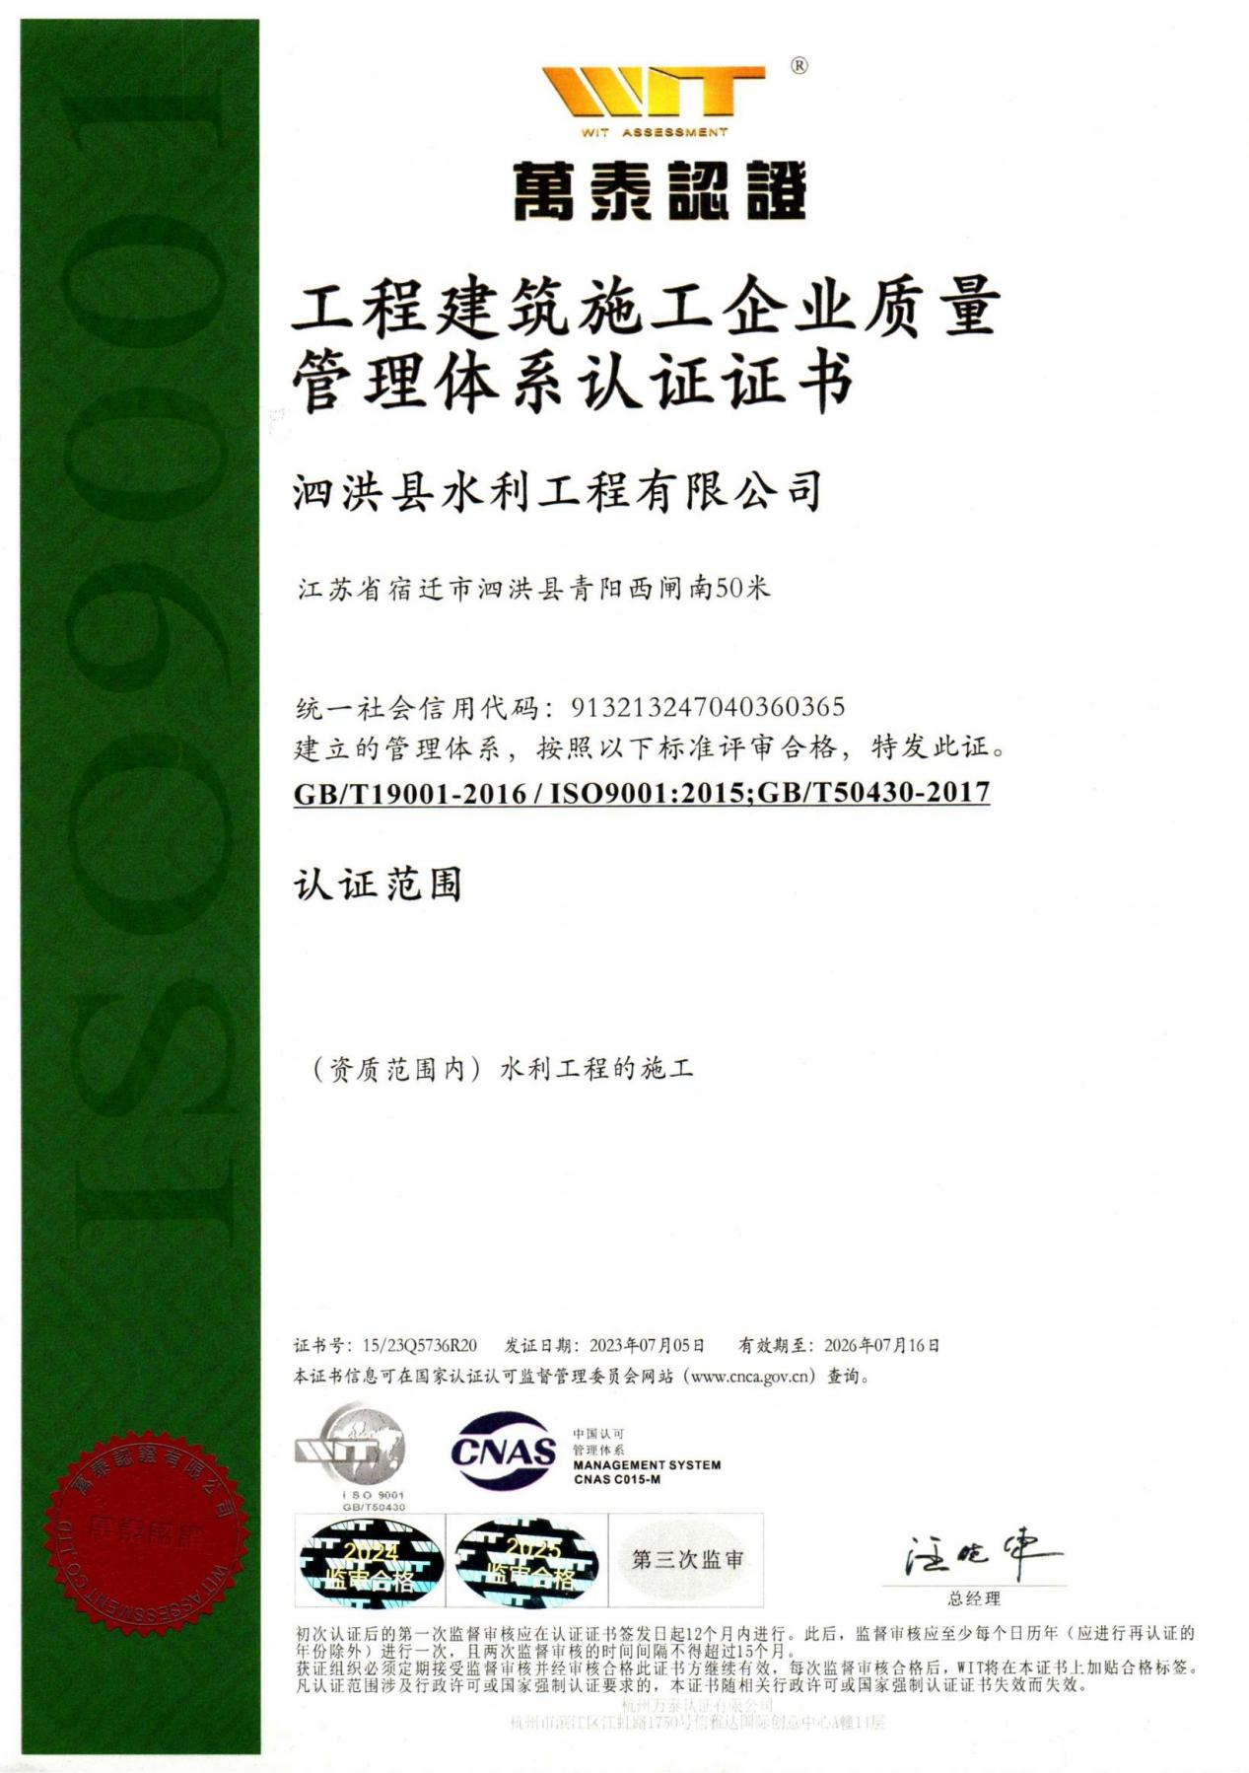

http://cx.cnca.cn/CertECloud/result/skipResultList?certNumber=&orgName=%E6%B3%97%E6%B4%AA%E5%8E%BF%E6%B0%B4%E5%88%A9%E5%B7%A5%E7%A8%8B%E6%9C%89%E9%99%90%E5%85%AC%E5%8F%B8&fromIndex=true
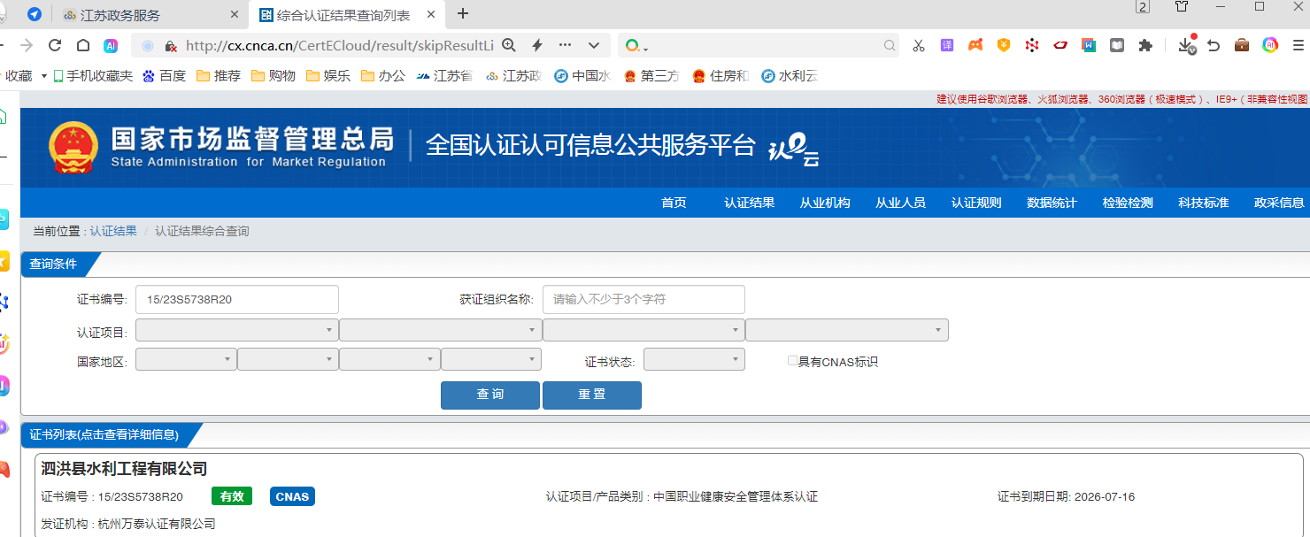

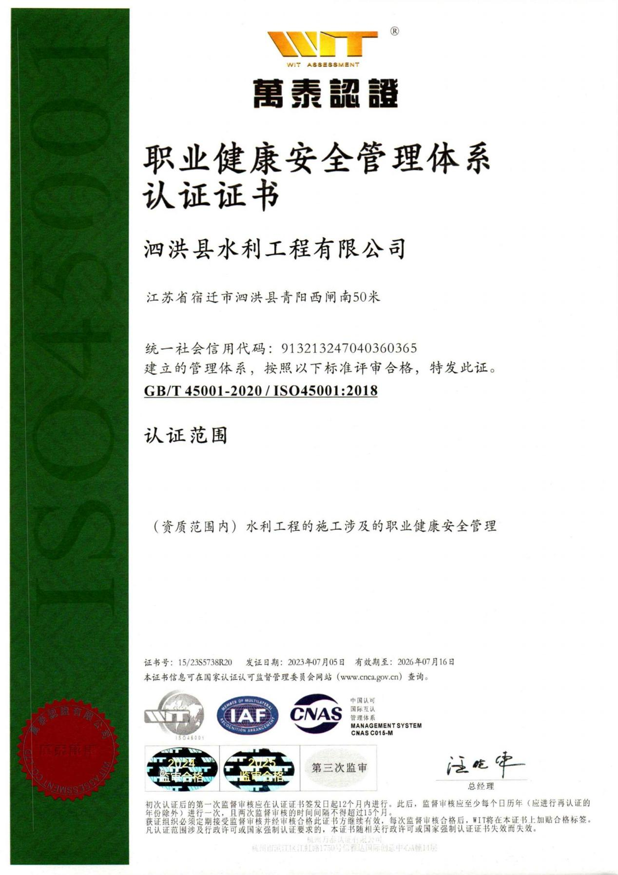

http://cx.cnca.cn/CertECloud/result/skipResultList?certNumber=&orgName=%E6%B3%97%E6%B4%AA%E5%8E%BF%E6%B0%B4%E5%88%A9%E5%B7%A5%E7%A8%8B%E6%9C%89%E9%99%90%E5%85%AC%E5%8F%B8&fromIndex=true
